Software Capstone Project Proposal: College Course Tracker Mobile Application

Table of Contents
Business Problem…………………………….. 3
The Customer ………………………………… 4
Business Case ……………………………….. 5
Fulfilment ……………………………………... 6
SDLC Methodology …………..………………. 7
Deliverables ……………………...……………. 8
- Project Deliverables ………….. 8
- Product Deliverables …………. 9
Deployment Plan and Outcomes ….………… 9
Project Timeline ……………...………………… 12
Environments and Costs ………………………. 8
Human Resource Requirements ……………… 14
Validation & Verification ………………………... 14
Professional Communication & Conclusion ….. 16

Business Problem
In the modern educational environment, undergraduates often must juggle multiple responsibilities at the same time: from working to spending time with friends to studying for classes. This all comes down to time management. The traditional methods – using a handwritten planner, simple calendar software, or basic note-taking software – do not have built-in academic tracking features that can support dynamic course layouts, the dates of each term, and the schedule of assessments (Fu et al., 2025).
Among students, the disorganization is linked to the absence of assignments, the lack of motivation, and the reduction of academic results. Despite the popularity of Canvas and Blackboard, their primary operation is a communication channel instead of all-encompassing personal productivity. These systems are not sufficient in providing a single experience that will enable students to handle every aspect of their academic program in an independent way.
The College Course Tracker Mobile Application aims to fill this gap to enable students to plan, monitor, and assess their academic obligations in a single, centralized, and automated platform. The system compiles course schedules, instructor details, and assessment data into a single, easily accessible portal. By streamlining each student’s terms, courses, and assessments, College Course Tracker aims to enhance the users’ time management and organizational skills.
College Course Tracker will transform disorganized academic schedules into manageable action plans by putting in place organizing classes into visually explainable notifications, simple visual tracking systems, and an extensive academic calendar. The plan gives students the ability to manage their time effectively, take responsibility for their actions, and take charge of their learning styles.
The Customer
College Course Tracker caters to students in colleges and universities throughout the United States and educational establishments that desire a powerful online planning instrument for their curriculum. Higher education students usually have the burden of multiple courses with different start and finish dates, and therefore, properly tracking due dates and deadlines can become complicated. College Course Tracker reacts to this need with the help of an interactive mobile platform that makes it easy to organize academic activities and improve productivity overall.
The main beneficiary group of the application includes undergraduate and graduate students aged between eighteen and thirty-five years who consider enrolling in institutions with an emphasis placed on online classes and remote learning. The possible institutional adopters include universities and community colleges that want to enhance the retention and achievement outcomes of students. The platform will ensure accessibility and scalability by providing individual and institutional levels of deployment.
Since many higher-education institutions are already using learning management systems and cloud-based infrastructure, the platform can be integrated easily. The application can be distributed as a direct application to students through app stores or markets as a licensed and institution-branded version. The mission of the app is to improve the performance of students and to ensure a high level of academic engagement, which is long-term and facilitated through technology.
The flexibility of the app allows users to customize their experience, and the institutions can track the trends of engagement so that they can use the data in academic planning. With the growing number of students juggling school and work remotely, this app is a welcome addition to a student’s toolbelt for success.
Business Case
The rationale behind the app is to solve a long-standing and measurable problem of time management. Studies show that students without an organizational structure are likely to miss assignments and demonstrate lower levels of academic success. The lack of organized study practices not only impacts negatively on grades but also creates an increased level of anxiety, burnout, and withdrawal rates.
The platform combines course management and grading monitoring, accompanied by notifications, all in one. It focuses on simplicity and efficiency, which allows users to be able to create academic terms, control courses, and start assignments in seconds. The course profile summarizes the information about the instructor, the communication channels he/she prefer, and the progress indicators. In addition, the assessment time is automatically adjusted in response to changes in the calendar, and thus, the task is maintained in view, and reminders are promptly made.
The College Course Tracker has benefits to the universities as well: Academic advisers can use the application as a personal scheduling assistant to reduce the use of manual scheduling. Analytics that are built into the tool allow the universities to identify behavioral trends such as submissions that are late and periods of inactivity, which can signal students who may need additional attention. This information-based understanding can help to improve the performance of students in terms of academic support.
The College Course Tracker is a sustainable business model as well. It uses a licensing model that can be used at both the enterprise and personal levels. This two-sided strategy ensures financial stability as well as accessibility.
The College Course Tracker is set to fill the gap that exists between technology and productivity by meeting the digital needs of the students and reducing disorganization. The business case is not only viable commercially but academically as well.
Fulfilment
The College Course Tracker achieves its mission by providing an interactive and mobile solution that has been designed specifically for academia. The application is designed on Microsoft’s .NET Multi-platform App UI (MAUI) platform, and it works on Android (potentially ported over to iOS as well) (Microsoft, 2025).
The interface of the app is user-friendly. When starting the application, users are met with a customized dashboard with up-to-date terms and course statuses, and assignments. On the term homepage, the students can add additional academic terms with a date-picker option system that allows the students to define the starting and ending dates. There are typically six courses in each term – though this can be modified - and the user can move freely between the courses to control the detailed information.
Courses have fields that can be edited to include the course title, instructor contact information, and notes, which are created and added by either the instructor or student. Students are also able to indicate the status of each course, such as ‘In-Progress’, ‘Completed’, and ‘Dropped’, using a selection tool. Assessments are located there as well: The course will typically have one performance assessment and one objective assessment. The students can also set notifications for the start and end of the assignment due dates, enabling the student to keep the approaching deadlines in mind throughout the day.
The notification feature was installed with the help of the LocalNotification library, which was used to provide real-time notifications about assessment deadlines and term/course start and end dates. Also, the students will be provided with the ability to share course notes with instructors or classmates using built-in sharing features.
The app also includes offline capability and automatically syncs when a network connection is restored, thus maintaining the integrity of the student’s notes/progress regardless of the current connection status. Using the built-in API, the app can communicate with the Canvas/Blackboard calendars, allowing a seamless integration of the College Course Tracker (Microsoft, 2022).
SDLC Methodology
The College Course Tracker will adopt the Waterfall model. This model aligns with the deliverables of the project: Waterfall offers the advantages of documentation and simple tracking of progress that can be used by a smaller group in order to create the app successfully.
The process begins with the requirements stage: We gather the requirements of the end-users, software functionality, and technical boundaries. Then there is the design phase, where wireframes, drawings, and database schemas are created. The implementation of these designs is done using C# and XAML along with the .NET MAUI framework. Once the app has been created, we reach the verification phase, whereby we conduct unit, integration, and acceptance tests to verify that all things are going well. Finally, we are in the maintenance phase where we correct errors, perfect features, and provide user contracts. The waterfall model shows clear visibility and progress checkpoints due to the sequential flow of the model.
The step-by-step design of the waterfall method offers a clear indicator of progress. The successful completion of one phase acts as the basis of the next phase, reducing ambiguity and scope creep. Since the requirements of the College Course Tracker are straightforward, iterative Agile sprints are not required. Instead, the Waterfall method creates a structured workflow that results in a high-quality end product.
Deliverables
The deliverables of the College Course Tracker work in tandem with the waterfall development process, where every stage gives a tangible output and the accompanied documentation that can be assessed. The process will produce project and product deliverables, in accordance with what was agreed upon ahead of time.
Project Deliverables
- The Requirements Specification will specify the entire functional and non-functional aspects of the College Course Tracker, providing a clear background for the design and development stages.
- A project schedule will identify milestones, dependencies, and due dates, and help the team track the progress.
- The Risk Management Plan will also be used to assess risks, and mitigation plans will be put in place to counter those risks.
- A detailed test plan will define test cases, test acceptance criteria, and a general validation plan to ensure that the software is reliable.
Product Deliverables
- Wireframes and mockups will be used to describe the layout of the interface, user navigation flow, and current design choices.
- A prototype or Minimum Viable Product (MVP) will demonstrate the core features of the application and will include course, term, and assessment management.
- The source code will reside on a public GitLab repository, and all versions and revisions will be visible to the public.
- A Deployment Guide will be used to provide instructions on how to build and publish the mobile application in a step-by-step format.
- The User Guide will guide end users and administrators on how to operate daily and use the key features.
- Finally, the Results Report on Quality Assurance will provide the summary results of the testing and will list the bugs that were fixed before the release.
Each milestone will involve a review of all the deliverables and version control. It is done to guarantee accountability, transparency, and documentation of the product professionally to both academic and industrial standards.
Deployment Plan and Outcomes
We will release a cross‑platform mobile application developed with Microsoft .NET Multi‑platform App UI (MAUI). This app provides students in higher education with a consolidated platform to store all academic terms, courses, and assessments, as well as information about their instructors and reminders of start/end dates and due dates. It also offers the option to sync the calendar with Canvas/Blackboard. The user’s information is locally stored in SQLite with an option to sync in the cloud. The application will work offline and reconcile when reconnected.
Deployment Process
The initial production target is Android. The build will be compiled in Release mode and packaged as a signed Android App Bundle (AAB) with an application‑specific keystore. The releases will be promoted in the following tracks on Google Play Console: Internal testing → Closed testing (UAT) → Production. Each promotion will require: (1) build number and semantic version update, (2) successful completion of automated smoke checks on the representative device matrix, (3) examination of Play Console pre‑launch reports, and (4) product owner approval. Production releases will be a staged rollout (e.g., 10%, then 50%, and then 100%) to minimize risks. The rollback plan consists of unpublishing the defective release and promoting the last known good build.
Configuration and Access
Environment‑specific configuration (API endpoints, analytics keys, notification channels) will use build‑time configuration files so that test builds cannot access production services. Privacy, data retention, and notification permissions are requested at first launch with clear explanations in the in‑app Privacy page.
Deployment Outcomes
At production rollout, end-users shall have access to the app in Google Play and shall be able to: (a) create/manage terms and courses, (b) add performance and objective assessments, (c) create date‑based reminders/notifications, and (d) access a master academic calendar. Institutions may elect to receive a branded build with preconfigured options. Operational outcomes include release notes visible in the store listing, crash and ANR monitoring through Play Console, and analytics dashboards to track adoption and engagement.
Post‑Deployment Support and Materials
The following assets shall be provided and sustained as necessary to support the live product: first, the User Guide (HTML/PDF) linked from the app’s Help menu that explains setup and adding courses/assessments, and how to manage notifications. Also, a Quick‑start video (≤3 minutes) is stored alongside the documentation site for onboarding. Knowledge Base/FAQ of existing common tasks and troubleshooting steps (how to enable a notification channel, restore from backup, etc.). Technical Deployment Guide documenting signing, versioning, store listing assets, and tracking promotion steps for release managers. Administrator Guide for the institutional partner describing the SSO/branding options and data governance expectations. Multiple support channels, such as email/ticketing during business hours with a 1‑business‑day initial response SLA and an emergency path for critical incidents.
Maintenance and Update Strategy
Security vulnerabilities and errors that are found in released applications will be addressed in patches with bug fixes and enhancements using semantic versioning (MAJOR.MINOR.PATCH). Errors to be addressed are managed in the backlog, which includes a process of vetting. Once the error has been addressed, the fix will then be verified and packaged in a new AAB. The new AAB is then tested against the internal track or closed track before being released to market via staged rollout. The health of the release is monitored over a period of seven days to identify if there are any errors in the release. Once errors are identified and the error rates exceed certain thresholds, a rollback is performed on the release, and a hotfix will be created.
Project Timeline
The project plan provides the flow of events with a start and an endpoint. Its stages comply with the project management rules and timeframes.
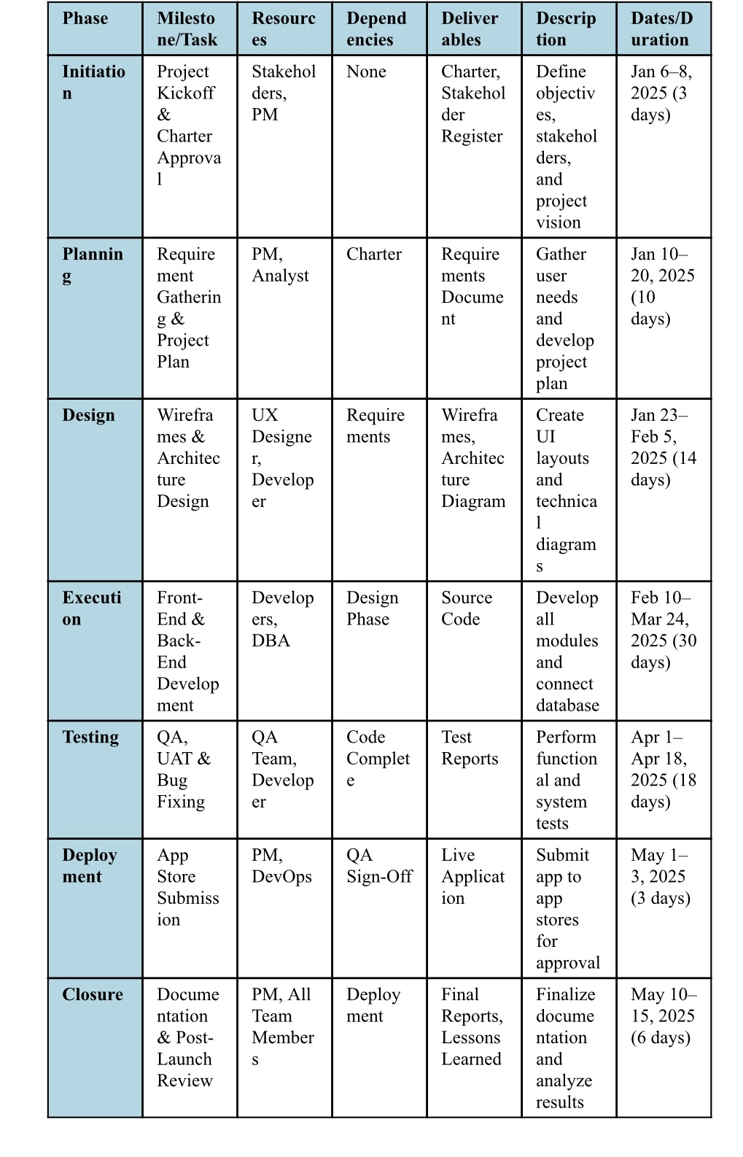
The time scale shows that the entire project will take ~five months upon completion of the deliverables.
Environments and Costs
The College Course Tracker will be constructed based on stable, open-source, and low-cost technologies. The development environment will utilize Windows 11, Visual Studio 2022, and the MAUI framework. User data will be kept locally in SQLite and optionally on Azure Cloud. GitLab will be used to manage version control, while xUnit will be used to conduct automated testing. The target of deployment is currently the Google Play Store. The approximate cost of the environment and functioning costs is:
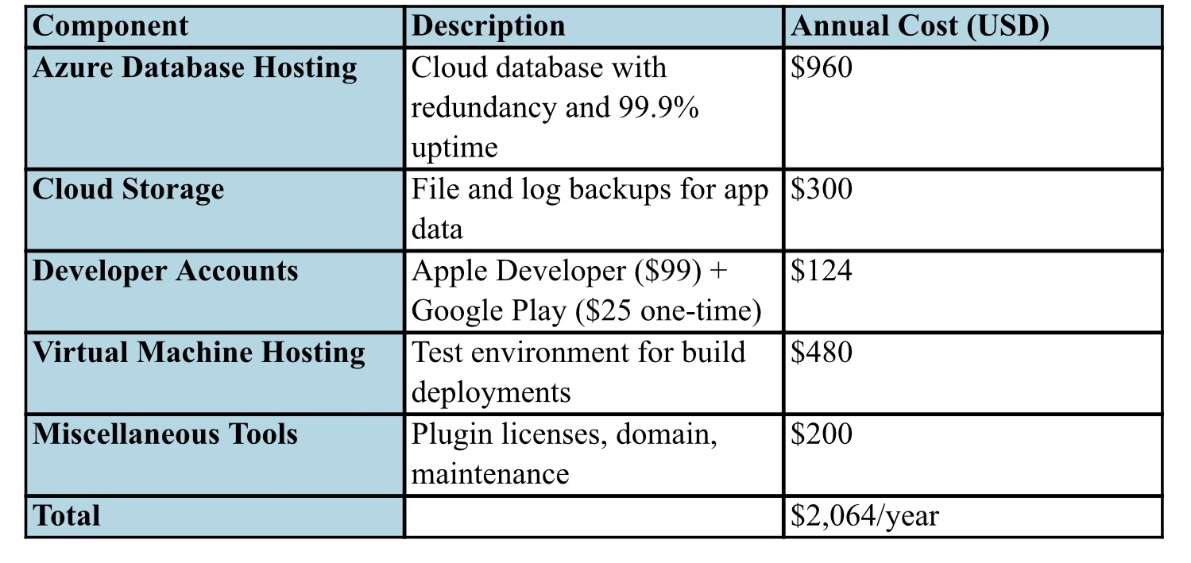
With this budget, the College Course Tracker can be used by small institutions and academic applications alike.
Human Resource Requirements
The staff will be composed of a product manager, software developers, UX designers, quality assurance testers, and subject matter experts.
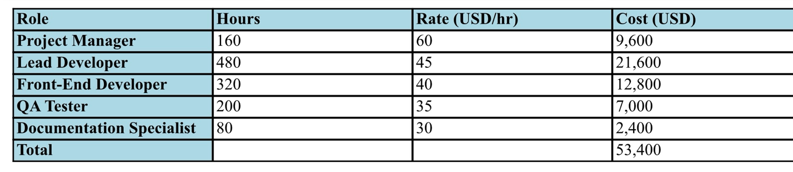
The above chart demonstrates the entire cost of the five-month project, including planning, development, testing, and reporting, followed by monitoring after release.
Validation & Verification
A series of layers of deliverable test coverage will proceed through a short, repeatable build–test–fix–retest cycle, with clear roles to ensure accountability. The developer delivers functionality, writes unit tests, reproduces defects, performs a documented root-cause analysis, and implements a fix. The QA analyst owns the test plan, executes scripted cases, and verifies fixes. While the release manager controls branches, environments, and promotions, the product owner or user representative defines acceptance criteria and signs off on user acceptance testing. Test coverage proceeds in layers: unit tests exercise core view models and services to catch logic errors early; integration tests verify data, notification, and calendar-sync contracts; system tests walk full workflows such as creating terms, adding courses and assessments, setting reminders, and confirming notifications
A focused regression suite is rerun each release, with lightweight performance, security/privacy, and accessibility checks to confirm startup, permissions, storage, and usability meet baseline expectations. Source control uses feature/*, release/*, and main branches. Continuous integration builds on each push and runs automated tests, then artifacts progress from internal testing to a staging environment that mirrors production and, finally, to a UAT track for user review. Defects move through a strict lifecycle: discovery and logging with evidence; triage and assignment; reproduction and isolation; explicit root-cause analysis with scope of impact; code fix with added or adjusted tests; peer review; and QA verification in staging before the release manager promotes.
Testing is complete only when all stories meet acceptance criteria and pass UAT, no Critical/High defects remain, core logic meets the agreed unit-test baseline with green CI, the regression suite passes in staging, and release notes and a rollback plan are prepared. This layered approach with mandatory root-cause analysis, controlled environments, and explicit exit criteria reduces risk, prevents recurrence, and provides traceable evidence that the product is ready to ship.
Professional Communication and Conclusion
Professional communication and documentation are essential components of the College Course Tracker project. All of the reports and documents will be formatted according to MLA style and professional writing style. Jira and Microsoft Teams will be used as project management tools that will provide the team with communication, progress monitoring, and version control.
The College Course Tracker Mobile Application is truly an innovative answer to the increasing problem of academic organization. The College Course Tracker provides students with the power to take charge of a learning process by combining the advantages of a centralized course management system, notifications, and easy integration with Canvas and Blackboard, among others. The waterfall SDLC methodology provides a well-planned, foreseeable, and responsible project process throughout development. The College Course Tracker, supported by a comprehensive deployment and testing plan, has a chance of being a successful and widely used app.
To summarize, because the need for organization is abundant, the College Course Tracker seems like a viable, practical, and effective solution.

